ST. XAVIER’S COLLEGE

**(Affiliated to Tribhuvan University)**

Maitighar, Kathmandu



COMPUTER GRAPHICS

Lab Assignment #4

**Submitted by:**

Lokendra Puri  
013BSCCSIT023

**Submitted to:**

|  |  |
| --- | --- |
| Er. Anil K. Sah  Lecturer |  |

Department of Computer Science

Date of Submission: August 18, 2015

**STATEMENT: WAP TO IMPLEMENT BRESENHAM’S LINE DRAWING ALGORITHM.**

**ALGORITHM:**

Step 1: Input line endpoints, (X1,Y1) and (X2, Y2)

Step 2: Calculate constants: ∆x = X2 – X1 ∆y = Y2 – Y1 2∆y 2∆y – ∆x

Step 3: Assign value to the starting parameters: k = 0 p0 = 2∆y – ∆x

Step 4: Plot the pixel at (X1, Y1)

Step 5: For each integer x-coordinate, xk, along the line

if pk < 0 plot pixel at ( xk + 1, yk )

pk+1 = pk + 2∆y

else

plot pixel at ( xk + 1, yk + 1 )

pk+1 = pk + 2∆y – 2∆x

increment k while x k < X2

**SOURCE CODE:**

//---------------------------------------------------------------------------

#include <vcl\vcl.h>

#pragma hdrstop

#include "Unit1.h"

//---------------------------------------------------------------------------

#pragma resource "*.dfm"

TForm1 *Form1;

//---------------------------------------------------------------------------

__fastcall TForm1::TForm1(TComponent* Owner)

: TForm(Owner)

{

}

//---------------------------------------------------------------------------

void __fastcall TForm1::Button1Click(TObject *Sender)

{

int x,y,x1,y1,x2,y2,dx,dy, p,pk,ix,iy,i;

x1=StrToInt(Edit1->Text);

y1=StrToInt(Edit2->Text);

x2=StrToInt(Edit3->Text);

y2=StrToInt(Edit4->Text);

dx=abs(x2-x1);

dy=abs(y2-y1);

x=x1;

y=y1;

Image1->Canvas->Pixels[x][y]=RGB(10,100,255);

p=2*dy-dx;

for (i=1;i<=dx;i++)

{

if(p<0)

{

x=x1+1;

y=y1;

x1=x;

y1=y;

pk=p+2*dy;

Image1->Canvas->Pixels[x][y]=RGB(10,100,255);

}

else

{

x=x1+1;

y=y1+1;

x1=x;

y1=y;

pk=p+2*dy-2*dx;

Image1->Canvas->Pixels[x][y]=RGB(10,100,255);

}

} }

//------------------------------------------------------------------------

OUTPUT:

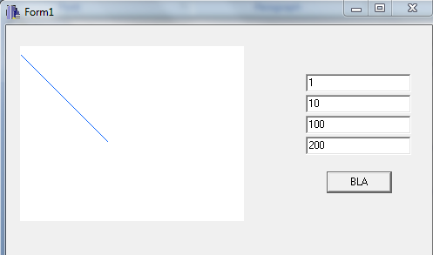

CONCLUSION:

Hence, BLA was implemented and above line was drawn.

REFERENCE:

1. <http://www.dailyfreecode.com/code/draw-line-bresenhams-line-algorithm-bla-721.aspx>
2. <http://www.embarcadero.com/products/cbuilder>